Julia for HPC
Student Setup Guide
WSL • Julia • Packages • PDE Solvers • Slurm
Setup order:

WSL2 → juliaup → Julia → Packages → PDE Workflow → VS Code → HPC / Slurm

Overview & Prerequisites
This guide walks you through setting up a complete Julia environment for scientific computing and HPC on Windows. Steps 1–3 install Julia and its package manager. Step 4 introduces the key PDE packages. Step 5 walks through the full PDE-solving workflow with worked examples. Steps 6–8 connect you to the HPC cluster and teach you to submit Slurm jobs.

WHY WSL? | Julia and HPC clusters both run on Linux. WSL2 gives you a real Linux environment inside Windows — the same commands, paths, and tools you will use on the cluster.

Time Estimate
Step | Estimated Time
Step 1 — Install WSL2 | 10–15 min
Step 2 — Install juliaup + Julia | 5–10 min
Step 3 — Install Julia Packages | 10–15 min
Step 4 — Learn PDE Packages | 15–20 min (reading)
Step 5 — PDE Workflow & Examples | 30–60 min (hands-on)
Step 6 — Configure VS Code | 5–10 min
Step 7 — Connect to HPC via SSH | 10 min
Step 8 — Submit Slurm Jobs | 10–15 min
Total | ~95–155 min

What You Need Before Starting
- A Windows 10 (version 2004+) or Windows 11 PC
- Administrator rights on your machine
- An active internet connection
- VS Code installed (download from code.visualstudio.com if not already installed)
- Your HPC cluster credentials (username + hostname) — provided by your instructor

Step 1 — Install WSL2 (Linux on Windows)
WSL2 (Windows Subsystem for Linux 2) runs a real Linux kernel inside Windows. This is the foundation for everything else in this guide.

NOTE | If you have already installed WSL2 with Ubuntu, skip to Step 2.

1.1 Enable WSL from PowerShell
Open PowerShell as Administrator (right-click the Start menu → Windows PowerShell (Admin)) and run:

wsl --install

# This command will:
# - Enable the WSL feature
# - Install the WSL2 Linux kernel
# - Install Ubuntu as the default distro

Restart your computer when prompted.

1.2 First Launch — Create a Linux User
After restart, Ubuntu will open automatically. You will be prompted to create a UNIX username and password:
- Username: use lowercase, no spaces (e.g. alice)
- Password: type it (nothing appears on screen — that is normal)
- Remember these credentials — you will use them inside WSL

1.3 Update Ubuntu & Install Essentials
In the Ubuntu terminal, run both commands:

sudo apt update && sudo apt upgrade -y
sudo apt install -y curl wget git build-essential

TIP | To open WSL any time, search for 'Ubuntu' in the Start menu, or type 'wsl' in any Windows terminal.

Step 2 — Install juliaup, then Julia
We use a two-step approach: first install juliaup (the official Julia version manager), then use juliaup to install Julia itself. This is the recommended workflow from the Julia developers and makes it trivial to upgrade or switch versions later.

WHY TWO STEPS? | juliaup is a small installer tool — think of it like pyenv for Python or nvm for Node. Once juliaup is installed, it handles downloading, installing, and switching between any Julia version with a single command.

2.1 Install juliaup
Run this in your WSL Ubuntu terminal:
curl -fsSL https://install.julialang.org | sh

# When prompted, press Enter to accept all defaults.
# juliaup will be installed to ~/.juliaup/bin

Reload your shell so the juliaup command is found:
source ~/.bashrc

# Verify juliaup is installed:
juliaup --version
# Expected: juliaup 1.x.x

2.2 Use juliaup to Install Julia
Now use juliaup to install the latest stable Julia release:
# Install the latest stable Julia
juliaup add release

# Set it as the default version
juliaup default release

# Verify Julia is now available
julia --version
# Expected: julia version 1.x.x

TIP | To match your HPC cluster's Julia version exactly: juliaup add 1.10.4 then juliaup default 1.10.4 — ask your instructor which version the cluster uses.

2.3 Useful juliaup Commands
Command | What it does
juliaup add release | Install the latest stable Julia
juliaup add 1.10.4 | Install a specific version
juliaup default 1.10.4 | Switch the default Julia version
juliaup list | List all installed Julia versions
juliaup update | Update juliaup and all installed versions
juliaup remove 1.9 | Remove an old version to free space

Step 3 — Installing Julia Packages
Julia's package manager (Pkg) is built into the language. You never need a separate tool like pip or conda. There are two ways to use it: interactive package mode in the REPL, or the Pkg API inside a script.

3.1 The Julia REPL and Package Mode
Launch Julia by typing julia in your terminal. The REPL (Read-Eval-Print Loop) is your interactive Julia session:
julia
# Welcome to Julia. You will see the prompt: julia>

# Press ] to enter package mode. The prompt changes to:
# (@v1.10) pkg>

# Press Backspace or Ctrl+C to return to the julia> prompt
# Press Ctrl+D to exit Julia entirely

TIP | The prefix (@v1.10) means you are in the global environment. When working on a project you will see the project name instead — more on this below.

3.2 Installing and Managing Packages
Inside package mode you can add, remove, update, and inspect packages:
# --- Inside package mode (after pressing ]) ---

# Add a single package
(@v1.10) pkg> add LinearAlgebra

# Add multiple packages at once
(@v1.10) pkg> add DifferentialEquations Plots BenchmarkTools

# Remove a package
(@v1.10) pkg> remove Plots

# Update all installed packages
(@v1.10) pkg> update

# List all installed packages
(@v1.10) pkg> status

# Pin a package to a specific version (useful for reproducibility)
(@v1.10) pkg> add DifferentialEquations@7.10.0

3.3 Project Environments (Best Practice)
For each project (e.g. your PDE solver), create an isolated environment so packages do not conflict between projects. This is always recommended for HPC work.
# Create and enter your project directory
mkdir -p ~/julia-pde && cd ~/julia-pde

# Launch Julia and activate a new environment for this project
julia --project=.

# Now inside package mode, packages install ONLY for this project:
(@julia-pde) pkg> add DifferentialEquations SparseArrays Plots

# Julia creates two files you should commit to git:
# Project.toml — lists your direct dependencies
# Manifest.toml — exact versions of everything (full reproducibility)

WHY THIS MATTERS | On HPC clusters, you always run julia --project=. so the cluster uses the exact same package versions as your local machine. This prevents 'it works locally but not on the cluster' problems.

3.4 Using Pkg from a Script (Non-Interactive)
You can also install packages from a Julia script or directly from the command line, which is useful for setup scripts:
# From inside julia> prompt (not package mode):
using Pkg
Pkg.add("DifferentialEquations")
Pkg.add(["Plots", "BenchmarkTools", "SparseArrays"])
Pkg.status() # show installed packages
Pkg.update() # update all

# One-liner from the terminal (useful in Slurm scripts):
julia -e 'using Pkg; Pkg.instantiate()'

Step 4 — Key Julia Packages for PDE Solving
The Julia ecosystem has a rich set of packages for scientific computing and PDE solving. Install the ones relevant to your course using the methods from Step 3. Below is a curated guide organized by category.

4.1 Core Math & Linear Algebra
These come with Julia's standard library — no installation needed, just use them:
using LinearAlgebra # dense matrix ops, factorizations (LU, QR, Cholesky)
using SparseArrays # sparse matrices — essential for large PDE systems
using FFTW # Fast Fourier Transform (spectral methods)

Package | Key Features
LinearAlgebra (stdlib) | Dense factorizations, eigenvalues, matrix norms, BLAS/LAPACK wrappers
SparseArrays (stdlib) | spdiagm, sparse(), CSC format, sparse direct solves with \
FFTW.jl | FFT / iFFT for spectral PDE methods; very fast on multi-core

4.2 The DifferentialEquations.jl Ecosystem
DifferentialEquations.jl is the most comprehensive PDE/ODE solver suite in any language. It covers ODEs, SDEs, DDEs, DAEs, and PDEs via the method of lines.
# Install the full suite (large but comprehensive):
(@julia-pde) pkg> add DifferentialEquations

# Or install only what you need (faster to install):
(@julia-pde) pkg> add OrdinaryDiffEq # ODE solvers (RK4, Rosenbrock, etc.)
(@julia-pde) pkg> add MethodOfLines # Automated method-of-lines for PDEs
(@julia-pde) pkg> add ModelingToolkit # Symbolic PDE specification

Sub-package | What it solves
OrdinaryDiffEq.jl | Time integration for u'=f(u,t): RK4, Tsit5, Rosenbrock, SDIRK, etc.
MethodOfLines.jl | Automatically discretizes PDEs in space, hands to OrdinaryDiffEq
ModelingToolkit.jl | Symbolically define PDEs, auto-generates fast Julia code
StochasticDiffEq.jl | SDEs and SPDEs with noise
BoundaryValueDiffEq.jl | Boundary value problems (shooting, collocation)

Example: solving the heat equation symbolically with MethodOfLines:
using ModelingToolkit, MethodOfLines, OrdinaryDiffEq, DomainSets

@parameters t x
@variables u(..)
Dt = Differential(t); Dxx = Differential(x)^2

eq = Dt(u(t,x)) ~ 0.01 * Dxx(u(t,x))
bcs = [u(0,x) ~ exp(-100*(x-0.5)^2),
u(t,0) ~ 0, u(t,1) ~ 0]
domain = [t ∈ (0,1.0), x ∈ (0,1.0)]

pdesys = PDESystem(eq, bcs, domain, [t,x], [u(t,x)])
disc = MOLFiniteDifference([x=>0.01], t)
prob = discretize(pdesys, disc)
sol = solve(prob, Tsit5())

4.3 Sparse Linear Solvers
Large PDE systems produce big sparse matrices. Choose the right solver for your problem size and structure:
(@julia-pde) pkg> add KrylovKit # Krylov iterative solvers (GMRES, CG, MINRES)
(@julia-pde) pkg> add IterativeSolvers # Classic Krylov methods + preconditioners
(@julia-pde) pkg> add Preconditioners # ILU, Jacobi, SSOR preconditioners
(@julia-pde) pkg> add Pardiso # Pardiso direct solver (requires license)

Solver / Package | Best for
A \ b (SparseArrays) | Small-to-medium problems; uses UMFPACK direct solver
KrylovKit.jl — GMRES | Large non-symmetric systems (Navier-Stokes, convection)
IterativeSolvers.jl — CG | Large symmetric positive-definite systems (Poisson, heat)
Preconditioners.jl — ILU | Preconditioner for GMRES/CG to speed up convergence

4.4 Finite Element Method (FEM)
For complex geometries and unstructured meshes, use dedicated FEM packages:
(@julia-pde) pkg> add Ferrite # Full FEM framework (recommended)
(@julia-pde) pkg> add Gridap # FEM with high-level DSL
(@julia-pde) pkg> add FerriteViz # Visualization of Ferrite solutions

Package | Description
Ferrite.jl | Finite element assembly, Lagrange/serendipity elements, multi-physics
Gridap.jl | High-level FEM DSL; write weak forms symbolically; parallel-ready
FerriteViz.jl | Post-processing and visualization of Ferrite FEM results

4.5 Fluid Dynamics (Navier-Stokes)
(@julia-pde) pkg> add Oceananigans # GPU/CPU ocean & fluid dynamics solver
(@julia-pde) pkg> add WaterLily # Differentiable CFD (immersed boundary)

Package | Description
Oceananigans.jl | Production-grade CFD/oceanography; Slurm + GPU-ready; incompressible NS
WaterLily.jl | Simple differentiable CFD; good for learning NS discretization

4.6 Visualization & Output
(@julia-pde) pkg> add Plots # General plotting (many backends)
(@julia-pde) pkg> add Makie # High-performance interactive plots
(@julia-pde) pkg> add CairoMakie # Makie backend for static publication figures
(@julia-pde) pkg> add GLMakie # Makie backend for interactive 3D plots
(@julia-pde) pkg> add WriteVTK # Export solutions to VTK for ParaView

TIP | For HPC post-processing: use WriteVTK.jl to save results, then open them in ParaView on your local machine. This avoids sending large plot files over SSH.

4.7 Performance & Parallelism
(@julia-pde) pkg> add BenchmarkTools # @btime, @benchmark macros
(@julia-pde) pkg> add ThreadsX # Drop-in parallel map/reduce using threads
(@julia-pde) pkg> add MPI # MPI bindings for multi-node HPC
(@julia-pde) pkg> add CUDA # GPU programming (NVIDIA cards only)
(@julia-pde) pkg> add KernelAbstractions # Write GPU/CPU-agnostic kernels

Package | When to use
BenchmarkTools.jl | Always — use @btime to measure before optimizing
ThreadsX.jl | Easy parallelism on a single node (shared memory)
MPI.jl | Multi-node parallelism on the HPC cluster
CUDA.jl | GPU-accelerated solvers on nodes with NVIDIA GPUs
KernelAbstractions.jl | Write one kernel that runs on CPU or GPU without changes

4.8 Recommended Package Install for This Course
Run this once after creating your project environment (Step 3.3):
# Inside your project: julia --project=.
# Then in package mode (press ]):

(@julia-pde) pkg> add OrdinaryDiffEq MethodOfLines ModelingToolkit
(@julia-pde) pkg> add LinearAlgebra SparseArrays FFTW
(@julia-pde) pkg> add KrylovKit IterativeSolvers
(@julia-pde) pkg> add Ferrite
(@julia-pde) pkg> add Plots CairoMakie WriteVTK
(@julia-pde) pkg> add BenchmarkTools MPI

# Precompile everything (run once, takes a few minutes):
(@julia-pde) pkg> precompile

Step 5 — The PDE Solving Workflow
Solving any PDE in Julia (or any language) follows the same five-stage pipeline. Understanding this workflow is essential: each stage has its own decisions, and errors at an early stage cascade through everything that follows. This section walks through each stage in detail, with worked examples for the heat, wave, and Poisson equations.

5.1 The Five-Stage Pipeline
Stage | Question Answered
1. Mathematical Model | What equation am I solving? What are the BCs and ICs?
2. Discretization | How do I convert continuous derivatives into finite operations?
3. Build the System | What matrices/vectors represent my discrete problem?
4. Choose & Run Solver | Direct, iterative, time-stepping? Which algorithm fits?
5. Visualize & Verify | Does the solution make physical sense? How does it converge?

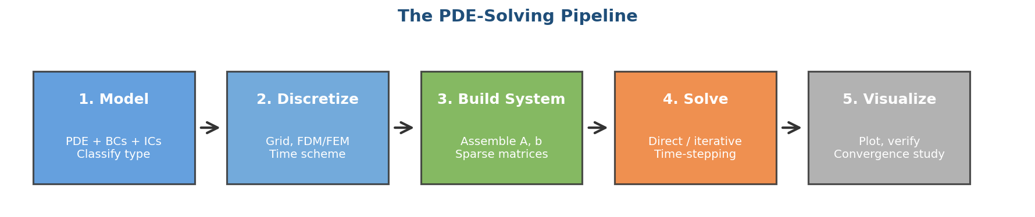
Figure 1. The five-stage PDE-solving pipeline. Each stage feeds the next; errors at early stages cascade through everything that follows.

KEY INSIGHT | Stages 2 and 3 are where most students make mistakes. Always verify each stage before moving to the next: print matrix sizes, check sparsity patterns, and test on a tiny grid first.

5.2 Stage 1 — The Mathematical Model
Before writing any code, write down the PDE, its domain, boundary conditions (BCs), and initial conditions (ICs). A complete problem statement has all four:

Element | Heat Equation Example
PDE | ∂u/∂t = α ∇²u
Domain | x ∈ [0, L], t ∈ [0, T]
Boundary conditions | u(0,t) = 0, u(L,t) = 0 (Dirichlet)
Initial condition | u(x,0) = sin(πx/L)
Parameters | α = 0.01 (diffusivity), L = 1, T = 1

PDE Classification — Why It Matters
The type of PDE determines which numerical methods will work. Always classify your PDE first:
Type | Characteristic / Examples
Parabolic | First-order in time, diffusive (Heat equation). Needs IC + BCs. Smooths over time.
Hyperbolic | Second-order or first-order with finite wave speed (Wave, advection). Needs IC + BCs. Preserves features.
Elliptic | No time derivative; equilibrium problem (Poisson, Laplace). Needs only BCs. One global solve.
Mixed / Nonlinear | Navier-Stokes (parabolic + nonlinear advection). Hardest — use specialized libraries.

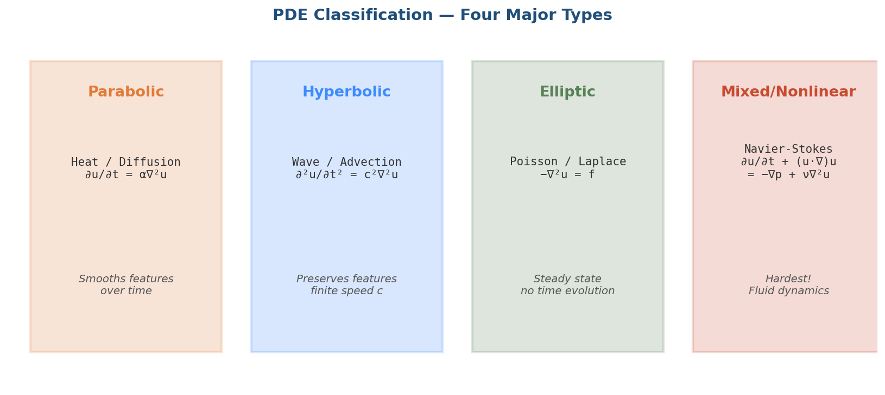
Figure 2. The four major PDE families covered in this course. Each behaves differently in time and space and demands a different numerical strategy.

Boundary Condition Types
BC Type | Form / Use case
Dirichlet | u = g on boundary (fixed value, e.g. T=0 at wall)
Neumann | ∂u/∂n = g on boundary (fixed flux, e.g. insulated wall)
Robin / Mixed | αu + β(∂u/∂n) = g (e.g. heat exchange with environment)
Periodic | u(0) = u(L) (e.g. ring, infinite domain approx)

TIP | Wrong BCs are the #1 cause of nonsense solutions. Always sanity-check: plot the boundary values from your discrete solution and confirm they match what you specified.

5.3 Stage 2 — Discretization
Computers cannot represent continuous derivatives, so we approximate them. Discretization splits both space and (for time-dependent PDEs) time into a finite grid, then replaces derivatives with finite differences, finite elements, or spectral expansions.

Spatial Discretization Methods
Method | When to use
Finite Difference (FDM) | Simple geometries (rectangles, cubes). Easiest to code. Use for this course.
Finite Element (FEM) | Complex geometries, unstructured meshes. Use Ferrite.jl or Gridap.jl.
Finite Volume (FVM) | Conservation laws (CFD). Built into many CFD codes.
Spectral / Pseudospectral | Periodic domains, very high accuracy. Use FFTW.jl.

Finite Difference Stencils (Most Common)
On a uniform grid with spacing h, replace continuous derivatives with these formulas:
# 1st derivative (central, 2nd-order accurate):
# du/dx ≈ ( u[i+1] - u[i-1] ) / (2h)

# 2nd derivative (central, 2nd-order accurate):
# d²u/dx² ≈ ( u[i+1] - 2u[i] + u[i-1] ) / h²

# 2D Laplacian (5-point stencil):
# ∇²u ≈ ( u[i+1,j] + u[i-1,j] + u[i,j+1] + u[i,j-1] - 4u[i,j] ) / h²

# 3D Laplacian (7-point stencil): same idea, 6 neighbors + center

Time Discretization (for parabolic & hyperbolic PDEs)
Scheme | Properties
Explicit Euler | Simple, fast per step, but tiny time step required (CFL limit). Conditionally stable.
Implicit Euler | Unconditionally stable, larger Δt allowed, but solves a linear system each step.
Crank-Nicolson | 2nd-order accurate, unconditionally stable. Best for diffusion problems.
Leap-frog | 2nd-order, popular for wave equations. Preserves energy.
RK4 / Tsit5 | High order, automatic step control. Use OrdinaryDiffEq.jl.

The CFL Condition (Critical!)
Explicit time-stepping schemes have a stability limit relating Δt and Δx. Violating it makes the solution explode within a few steps:
# Heat equation (1D), explicit Euler:
# dt ≤ dx² / (2α) ← strict! In 2D divide by 4, in 3D by 6.

# Wave equation (1D), explicit:
# dt ≤ dx / c ← less restrictive than heat

# Always pick dt with a safety factor:
dt = 0.4 * dx^2 / α # for heat — the 0.4 < 0.5 is safety margin

WARNING | If your solution suddenly becomes huge (1e30 or NaN) after a few iterations, you are violating CFL. Reduce dt and try again.

5.4 Stage 3 — Build the Discrete System (Matrices)
Once discretized, your PDE becomes either a linear system A u = b (elliptic) or a time-stepping rule du/dt = -A u + f (parabolic/hyperbolic after spatial discretization). Building these matrices correctly is critical.

Why Sparse Matrices?
A 1000×1000 grid has 10⁶ unknowns. The dense Laplacian would need 8 TB of RAM. But each row has only ~5 non-zeros, so the sparse version fits in ~40 MB. Always use SparseArrays for PDE matrices.

Example: Building the 1D Laplacian
using SparseArrays, LinearAlgebra

function laplacian_1d(N, h)
# Tridiagonal matrix: -2 on diagonal, 1 on off-diagonals
main_diag = fill(-2.0, N)
off_diag = fill( 1.0, N-1)
A = spdiagm(0 => main_diag, 1 => off_diag, -1 => off_diag)
return A ./ h^2
end

N, h = 100, 1/100
A = laplacian_1d(N, h)
println("Matrix size: ", size(A))
println("Non-zeros: ", nnz(A), " out of ", N*N)
println("Sparsity: ", round(100*(1 - nnz(A)/(N*N)), digits=2), "%")

Example: Building the 2D Laplacian via Kronecker Products
In 2D the Laplacian on an N×N grid can be elegantly built using Kronecker products of 1D operators:
using SparseArrays, LinearAlgebra

function laplacian_2d(N, h)
# 1D Laplacian (without 1/h² yet)
e = ones(N)
L1D = spdiagm(0 => -2*e, 1 => e[1:end-1], -1 => e[1:end-1])
I_N = sparse(I, N, N)
# 2D Laplacian = L⊗I + I⊗L
L2D = (kron(I_N, L1D) + kron(L1D, I_N)) / h^2
return L2D
end

N = 50
A = laplacian_2d(N, 1/N)
println("2D Laplacian: ", size(A), ", nnz=", nnz(A))

Applying Boundary Conditions
# DIRICHLET: u = g on boundary
# Method 1: Eliminate boundary unknowns (smaller system)
# Method 2: Replace boundary rows with identity (easier to code)

# Example: Dirichlet u=0 on left/right, set boundary rows:
A[1, :] .= 0; A[1, 1] = 1; b[1] = 0
A[end, :] .= 0; A[end, end] = 1; b[end] = 0

# NEUMANN: ∂u/∂n = g
# Use ghost-point trick: u[0] = u[2] - 2h*g (one-sided difference)
# Or modify the stencil at the boundary

5.5 Stage 4 — Choose and Run a Solver
With your system built, pick a solver based on the PDE type, system size, and matrix structure. The right choice can mean the difference between minutes and days of compute time.

Decision Tree
Your situation | Recommended solver
Elliptic, N < 10⁴ unknowns | Direct: u = A \ b (UMFPACK, built into Julia)
Elliptic, symmetric, large N | CG (Conjugate Gradient) from IterativeSolvers.jl
Elliptic, non-symmetric, large N | GMRES from KrylovKit.jl, with ILU preconditioner
Parabolic (heat), small N | Explicit Euler with dt < CFL limit
Parabolic, large N or stiff | Crank-Nicolson, or use OrdinaryDiffEq's Rosenbrock23()
Hyperbolic (wave) | Leap-frog, or OrdinaryDiffEq with Tsit5() / Vern7()
Nonlinear / Navier-Stokes | Newton iteration + GMRES, or use Oceananigans.jl

Four Worked Examples (full pipeline)

Example A: Heat Equation (Parabolic) — Full Pipeline
∂u/∂t = α ∇²u, on x ∈ [0,1], with u(0)=u(1)=0 and u(x,0)=sin(πx).
using LinearAlgebra, SparseArrays, Plots

# === Stage 1: Model ===
α = 0.01; L = 1.0; T_final = 5.0

# === Stage 2: Discretization ===
N = 100
dx = L / (N+1) # interior spacing
dt = 0.4 * dx^2 / α # CFL-safe time step
x = range(dx, L-dx, length=N) # interior grid points
nsteps = Int(ceil(T_final / dt))

# === Stage 3: Build system ===
e = ones(N)
A = spdiagm(0 => -2*e, 1 => e[1:end-1], -1 => e[1:end-1]) ./ dx^2

# Initial condition
u = sin.(π .* x)
u_history = [copy(u)] # save snapshots for plotting

# === Stage 4: Solve (explicit time-stepping) ===
for step in 1:nsteps
u .= u .+ dt * α * (A * u)
if step % 50 == 0
push!(u_history, copy(u))
end
end

# === Stage 5: Visualize ===
plot(x, u_history, label="", xlabel="x", ylabel="u(x,t)",
title="Heat equation: diffusion over time", lw=2)
savefig("heat_solution.png")

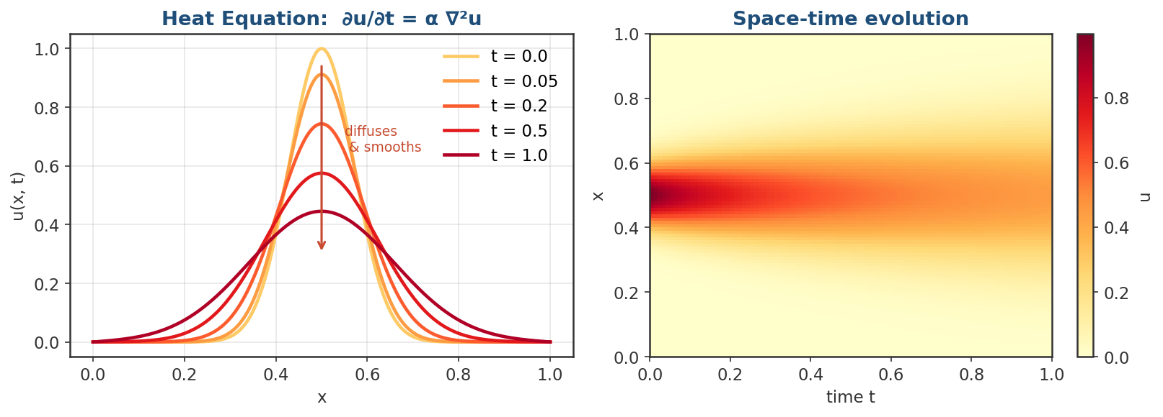
Figure 3. Heat equation: a Gaussian pulse centered at x=0.5 diffuses outward. Left: line plots at increasing times. Right: space-time heatmap showing the smoothing characteristic of parabolic PDEs.

Example B: Wave Equation (Hyperbolic) — Full Pipeline
∂²u/∂t² = c² ∇²u, on x ∈ [0,1], with u(0)=u(1)=0, plucked initial shape.
using LinearAlgebra, SparseArrays, Plots

# === Stage 1: Model ===
c = 1.0; L = 1.0; T_final = 2.0

# === Stage 2: Discretization (leap-frog) ===
N = 200
dx = L / (N+1)
dt = 0.4 * dx / c # CFL: dt < dx/c
x = range(dx, L-dx, length=N)
λ = (c * dt / dx)^2 # Courant number squared
nsteps = Int(ceil(T_final / dt))

# === Stage 3: Build system (Laplacian operator) ===
e = ones(N)
A = spdiagm(0 => -2*e, 1 => e[1:end-1], -1 => e[1:end-1])

# Initial conditions: triangular pluck, zero velocity
u_prev = [xi < 0.5 ? 2*xi : 2*(1-xi) for xi in x] # plucked shape
u_curr = copy(u_prev) # zero velocity → same as prev
u_next = similar(u_curr)

snapshots = [copy(u_curr)]

# === Stage 4: Solve (leap-frog time-stepping) ===
for step in 1:nsteps
u_next .= 2*u_curr .- u_prev .+ λ .* (A * u_curr)
u_prev, u_curr = u_curr, u_next
if step % 100 == 0
push!(snapshots, copy(u_curr))
end
end

# === Stage 5: Visualize ===
anim = @animate for u in snapshots
plot(x, u, ylim=(-1.2, 1.2), lw=2, legend=false,
title="Wave equation", xlabel="x", ylabel="u")
end
gif(anim, "wave_solution.gif", fps=15)

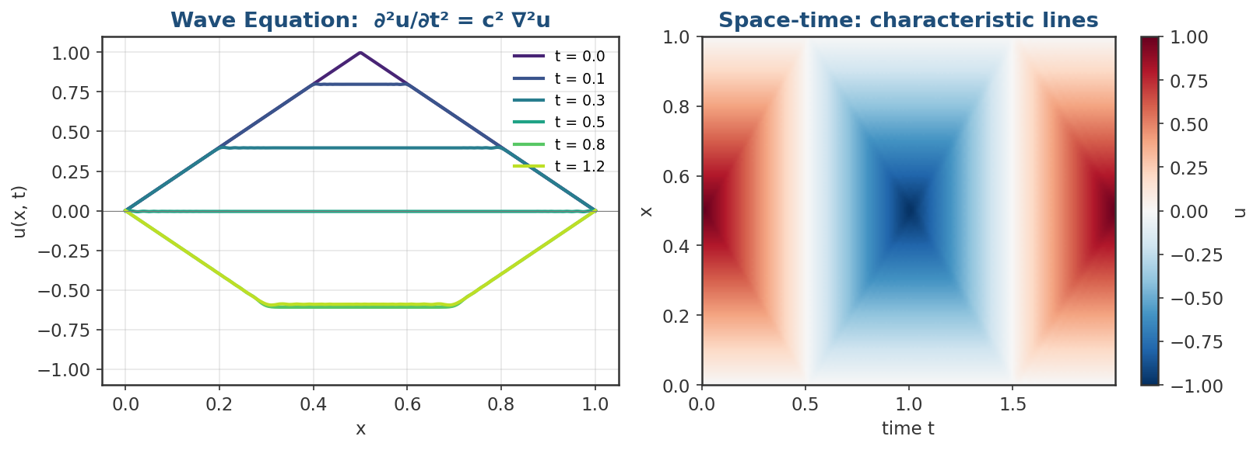
Figure 4. Wave equation: a triangular pluck splits into two waves traveling in opposite directions, then reflects off the boundaries. Right: characteristic lines visible in the space-time plot. Hyperbolic PDEs preserve features rather than smoothing them.

Example C: 2D Poisson Equation (Elliptic) — Full Pipeline
-∇²u = f on the unit square, u = 0 on boundary, f(x,y) = 2π² sin(πx) sin(πy).
using LinearAlgebra, SparseArrays, Plots

# === Stage 1: Model ===
L = 1.0
f_func(x, y) = 2*π^2 * sin(π*x) * sin(π*y)
u_exact(x, y) = sin(π*x) * sin(π*y) # known analytical solution

# === Stage 2: Discretization (5-point stencil) ===
N = 50 # interior points per side
h = L / (N+1)
xs = range(h, L-h, length=N)
ys = range(h, L-h, length=N)

# === Stage 3: Build 2D Laplacian via Kronecker products ===
e = ones(N)
T = spdiagm(0 => -2*e, 1 => e[1:end-1], -1 => e[1:end-1])
I_N = sparse(I, N, N)
A = -(kron(I_N, T) + kron(T, I_N)) / h^2 # negative Laplacian

# Right-hand side vector (column-major order)
b = [f_func(x, y) for y in ys, x in xs] |> vec

# === Stage 4: Solve (sparse direct solve) ===
@time u = A \ b
U = reshape(u, N, N)

# === Stage 5: Visualize and verify ===
p1 = heatmap(xs, ys, U, title="Numerical solution", aspect_ratio=1)
U_exact = [u_exact(x, y) for y in ys, x in xs]
p2 = heatmap(xs, ys, U .- U_exact, title="Error vs exact", aspect_ratio=1)
plot(p1, p2, layout=(1,2), size=(900, 400))
savefig("poisson_solution.png")

println("Max error: ", maximum(abs.(U .- U_exact)))

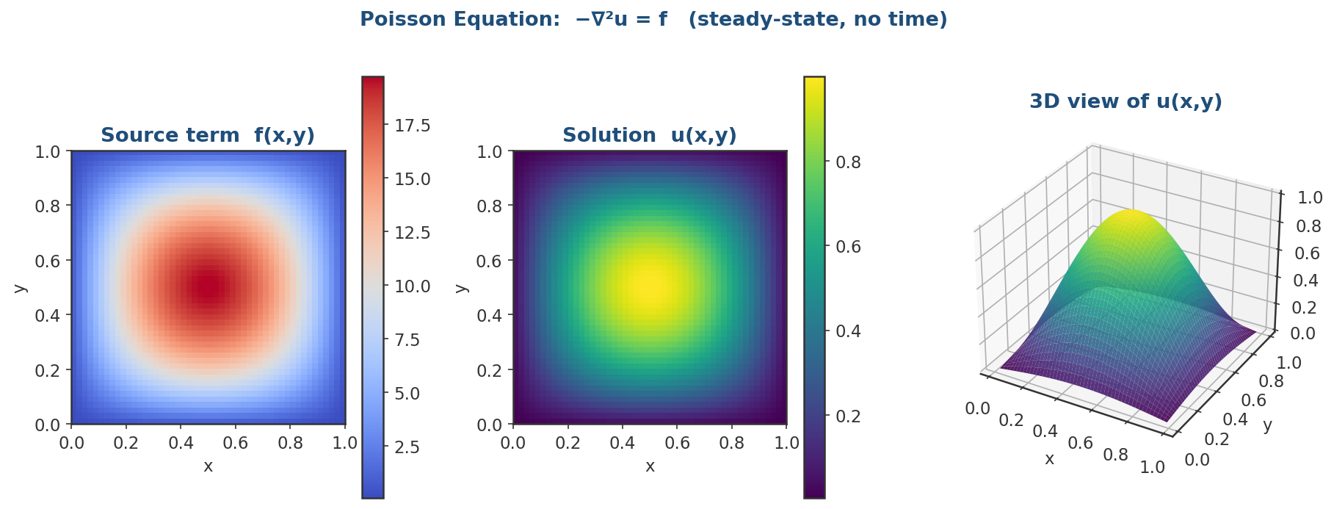
Figure 5. Poisson equation: source term f drives the solution u. With zero Dirichlet boundary conditions, the steady-state response is shown both as a heatmap and as a 3D surface. Elliptic PDEs have no time evolution — the solution is computed in a single sparse linear solve.

Example D: Navier-Stokes (Fluid Dynamics) — The Hard One
The Navier-Stokes equations describe how fluids (air, water, blood, etc.) flow. They are the most challenging PDE in this course because they are nonlinear, couple multiple unknowns (velocity and pressure), and admit turbulent solutions at high Reynolds numbers.

The Equations
For an incompressible fluid with velocity field u = (u, v, w) and pressure p:
∂u/∂t + (u·∇)u = -∇p/ρ + ν∇²u + g ← momentum (Newton's 2nd law)

∇·u = 0 ← incompressibility

Where:
u(x,t) : velocity vector field
p(x,t) : pressure scalar field
ρ : fluid density (constant)
ν : kinematic viscosity
g : body forces (e.g. gravity)

Physical Meaning of Each Term
Term | What it represents
∂u/∂t | Local acceleration (how velocity changes in time at a fixed point)
(u·∇)u | Convective acceleration (nonlinear!) — fluid carrying its own momentum
-∇p/ρ | Pressure gradient force (fluid pushed from high to low pressure)
ν∇²u | Viscous diffusion (friction smoothing the velocity field)
g | External body forces (gravity, electromagnetic, etc.)
∇·u = 0 | Mass conservation: incompressibility constraint

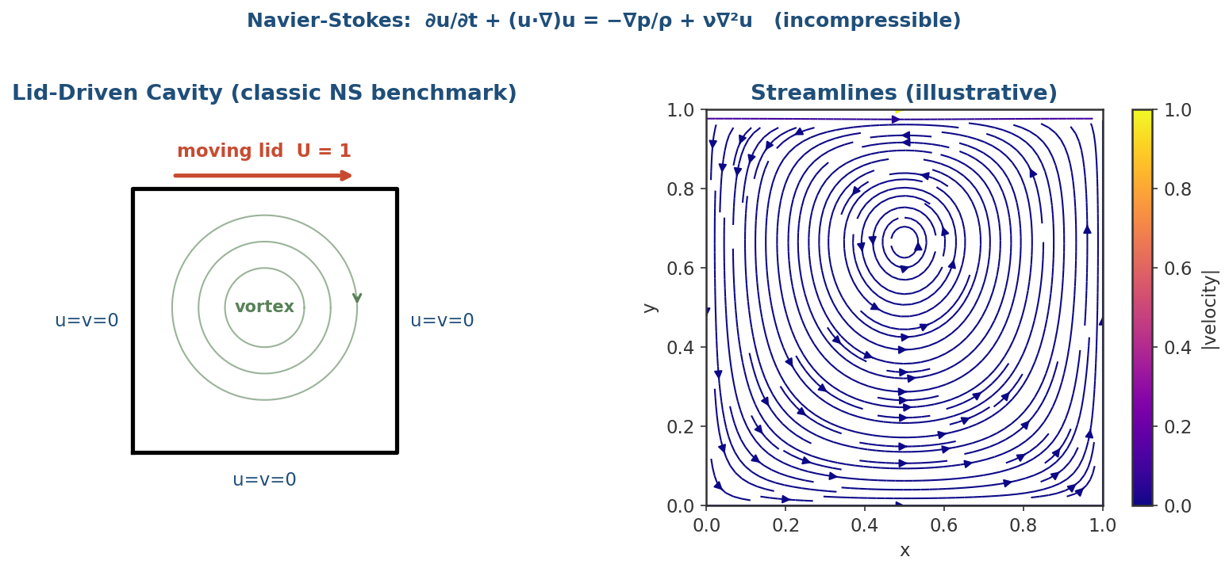
Figure 6. Lid-driven cavity — the classical NS benchmark. A square cavity has a moving lid (top) and stationary walls. The shearing motion of the lid drags fluid into a primary vortex. Right: streamlines visualizing the flow pattern.

Why Navier-Stokes Is So Difficult
- Nonlinear convective term (u·∇)u — cannot apply linear superposition; small changes in input can cause huge changes in output.
- Velocity-pressure coupling — pressure has no time derivative; instead it acts as a Lagrange multiplier enforcing ∇·u = 0. Special algorithms (projection methods, SIMPLE, fractional step) are needed.
- Stiff nonlinearity at high Reynolds numbers (Re = UL/ν) leads to turbulence — chaotic, multi-scale behavior requiring very fine grids or turbulence models (RANS, LES, DNS).
- CFL condition is more restrictive: dt depends on both convection (dt < dx/U) and diffusion (dt < dx²/ν).
- The Millennium Prize problem — nobody has proven that 3D smooth solutions always exist. This is genuinely an open math problem!

Solution Strategies in Julia
Approach | When to use it
Projection method by hand | Educational — learn the algorithm yourself in pure Julia
MethodOfLines.jl + DifferentialEquations.jl | Simple geometries; auto-discretizes 2D NS
WaterLily.jl | Differentiable CFD; great for learning, immersed boundary
Oceananigans.jl | Production CFD; CPU/GPU; scales on HPC clusters with MPI
Trixi.jl | High-order discontinuous Galerkin; compressible NS, hyperbolic systems

Minimal NS Solver Skeleton (2D, Projection Method)
This is the structure of a pure-Julia NS solver. Full implementation runs to ~150 lines — see the course repository for the complete file.
using LinearAlgebra, SparseArrays, Plots

# === Stage 1: Model ===
Re = 100.0 # Reynolds number
ν = 1.0/Re
Lx, Ly = 1.0, 1.0
U_lid = 1.0 # lid velocity

# === Stage 2: Discretization (staggered MAC grid) ===
Nx, Ny = 64, 64
dx, dy = Lx/Nx, Ly/Ny
dt = 0.25 * min(dx^2/ν, dx/U_lid) # combined CFL

# === Stage 3: Build Poisson operator for pressure correction ===
L_p = build_pressure_laplacian(Nx, Ny, dx, dy) # sparse 2D Laplacian

# === Stage 4: Time-stepping (projection / fractional-step) ===
u, v, p = init_fields(Nx, Ny)
for step in 1:nsteps
# 1. Predictor: solve momentum without pressure
u_star, v_star = predict_velocity(u, v, dt, ν, dx, dy)
apply_velocity_BCs!(u_star, v_star, U_lid)

# 2. Pressure Poisson: enforce incompressibility
rhs = compute_div(u_star, v_star, dx, dy) ./ dt
p = L_p \ vec(rhs)

# 3. Corrector: project velocity onto divergence-free field
u, v = correct_velocity(u_star, v_star, p, dt, dx, dy)
apply_velocity_BCs!(u, v, U_lid)
end

# === Stage 5: Visualize streamlines ===
ψ = streamfunction(u, v, dx, dy)
contour(xs, ys, ψ, levels=20, aspect_ratio=1, fill=true)
savefig("cavity_streamlines.png")

RECOMMENDATION | For your course project, start with Oceananigans.jl rather than rolling your own NS solver. It is HPC-ready out of the box, supports Slurm + MPI + GPU, and has excellent tutorials at clima.github.io/OceananigansDocumentation.

5.6 Stage 5 — Visualization & Verification
Never trust a numerical solution without verification. There are three levels of checks every PDE solver should pass:

Level 1: Sanity Checks
- Plot the solution at a few time steps. Does it look physically reasonable?
- Check boundary values match your BCs exactly.
- Check conserved quantities: total mass, energy, momentum (depending on the PDE).
- Run with a tiny grid (N=10) first — should still produce a reasonable shape.

Level 2: Convergence Study
A correct numerical scheme converges to the true solution as the grid is refined. Test this:
# Run the solver at multiple resolutions and measure error
errors = Float64[]
hs = Float64[]
for N in [10, 20, 40, 80, 160]
h = 1.0/(N+1)
u_num = solve_poisson(N) # your solver function
u_true = exact_solution(N)
push!(errors, maximum(abs.(u_num .- u_true)))
push!(hs, h)
end

# Plot on log-log: slope reveals convergence order
plot(hs, errors, xscale=:log10, yscale=:log10,
marker=:o, label="L∞ error",
xlabel="grid spacing h", ylabel="error")
plot!(hs, hs.^2, label="h² reference", ls=:dash)
savefig("convergence.png")

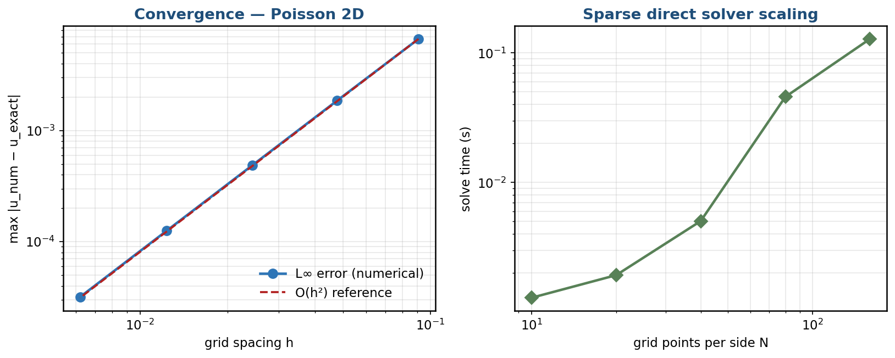
Figure 7. Live convergence study for the Poisson solver. Left: L∞ error tracks the O(h²) reference line on a log-log plot — confirming the scheme is 2nd-order accurate. Right: solve time grows roughly linearly in N² (number of unknowns) for a sparse direct solve.

EXPECTED ORDERS | Central differences → O(h²). Explicit Euler in time → O(Δt). Crank-Nicolson → O(Δt²). Linear FEM → O(h²) in L². If your slope is wrong, your code has a bug.

Level 3: Physical Validation
- Compare against an analytical solution if one exists (we did this for Poisson above).
- Compare against a published benchmark (lid-driven cavity for NS, etc.).
- Test conservation: total energy in the wave equation should stay constant.
- Check symmetry: if the problem is symmetric, the solution should be too.

Visualization Tools in Julia
Tool | Best for
plot() in Plots.jl | 1D line plots, 2D contour and heatmap
heatmap() / contour() | 2D scalar fields
surface() in Plots.jl | Quick 3D surface plots
Makie.jl | Publication-quality, interactive 3D, large data
@animate / gif() | Time-evolving solutions (heat, wave)
WriteVTK.jl + ParaView | 3D fields, complex meshes (production CFD output)

Saving Output for HPC Jobs
On HPC clusters you cannot view plots interactively. Save to file from your job script:
using Plots
ENV["GKSwstype"] = "100" # headless mode — no display required

# Save figures
savefig("results/solution_t$(t).png")

# Save raw data for later analysis
using JLD2
@save "results/run_$(jobid).jld2" u x t errors

# For 3D / large fields: use VTK
using WriteVTK
vtk_grid("results/poisson", xs, ys) do vtk
vtk["u"] = U
end

Step 6 — Configure VS Code for Julia + WSL
VS Code on Windows connects seamlessly to your WSL Linux environment. You will write and run Julia code in a familiar editor while it executes natively on Linux.

6.1 Install Required Extensions
Open VS Code, click the Extensions icon (Ctrl+Shift+X), and install:

Extension | Why You Need It
WSL (by Microsoft) | Connects VS Code to your WSL Linux environment
Julia (by julialang) | Syntax highlighting, IntelliSense, inline REPL
Jupyter (by Microsoft) | Run .ipynb notebooks with the Julia kernel
Remote — SSH | Connect directly to the HPC cluster from VS Code

6.2 Open Your WSL Workspace
- In VS Code press Ctrl+Shift+P and type: WSL: Connect to WSL
- A new VS Code window opens — the bottom-left corner shows [WSL: Ubuntu]
- Open your project: File → Open Folder → navigate to ~/julia-pde

6.3 Run Julia Inside VS Code
Open any .jl file, then press Alt+Enter to execute the current line or selection in the integrated Julia REPL. The Julia extension starts a REPL automatically on first use.
# Keyboard shortcuts in the Julia VS Code extension:
# Alt+Enter — Run current line / selection
# Ctrl+Enter — Run current block (cell)
# Shift+Enter — Run and move to next line
# Ctrl+Shift+P — Julia: Start REPL

Step 7 — Connect to the HPC Cluster
The HPC cluster runs Linux, accepts jobs via Slurm, and is accessed securely through SSH. Your instructor will provide the cluster hostname and your login credentials.

7.1 Generate an SSH Key
Using an SSH key is more secure and avoids typing your password every time:
# Run inside WSL terminal
ssh-keygen -t ed25519 -C "your_email@example.com"
# Press Enter to accept the default location (~/.ssh/id_ed25519)
# Optionally set a passphrase for extra security

# Copy your public key to the cluster:
ssh-copy-id user@cluster.example.edu

7.2 Connect and Test
ssh user@cluster.example.edu
# You should see the cluster welcome message

# Check that Julia is available (as a module):
module avail julia
module load julia/1.10
julia --version

# If Julia is not a module, install juliaup on the cluster too:
curl -fsSL https://install.julialang.org | sh && source ~/.bashrc
juliaup add release && juliaup default release

# Type 'exit' to disconnect

NOTE | Replace user and cluster.example.edu with the credentials given by your instructor.

7.3 Sync Your Project to the Cluster
Copy your local project (including Project.toml and Manifest.toml) to the cluster so it uses identical package versions:
# From your WSL terminal, push your project to the cluster:
rsync -avz ~/julia-pde/ user@cluster.example.edu:~/julia-pde/

# On the cluster, restore the exact package environment:
cd ~/julia-pde
julia --project=. -e 'using Pkg; Pkg.instantiate()'

7.4 Connect VS Code to the Cluster (Recommended)
- Press Ctrl+Shift+P → Remote-SSH: Connect to Host
- Enter: user@cluster.example.edu
- VS Code opens a remote session — browse, edit, and run files directly on the cluster

Step 8 — Submitting Julia PDE Jobs with Slurm
Slurm is the job scheduler on most HPC clusters. You write a shell script that describes your resource requirements, then submit it with sbatch. The scheduler queues your job and runs it when resources are available.

8.1 Slurm Concepts Cheat Sheet
Command / Flag | What it does
sbatch job.sh | Submit a job script to the queue
squeue -u $USER | Check your job status (R=Running, PD=Pending)
scancel <job_id> | Cancel a queued or running job
sinfo | See available partitions and node counts
--job-name | Label your job (shows in squeue)
--ntasks | Number of parallel tasks (MPI ranks)
--cpus-per-task | CPU cores per task (Julia threads)
--mem | Memory per node, e.g. 8G or 32G
--time | Max walltime HH:MM:SS — job is killed if exceeded
--partition | Queue/partition to submit to (ask your instructor)
--output / --error | File paths for stdout and stderr logs

8.2 Example: Heat Equation Job Script
Save this as heat_job.sh in your ~/julia-pde folder on the cluster:
#!/bin/bash
#SBATCH --job-name=heat_eq
#SBATCH --ntasks=1
#SBATCH --cpus-per-task=4
#SBATCH --mem=4G
#SBATCH --time=00:30:00
#SBATCH --output=heat_%j.out
#SBATCH --error=heat_%j.err

module load julia/1.10

# Run Julia with 4 threads, using the project environment
julia --threads=4 --project=. heat_equation.jl

8.3 Example: Multi-Node MPI Poisson Solver
#!/bin/bash
#SBATCH --job-name=poisson_mpi
#SBATCH --ntasks=4 # 4 MPI ranks across nodes
#SBATCH --cpus-per-task=2 # 2 threads per rank
#SBATCH --mem=16G
#SBATCH --time=01:00:00
#SBATCH --output=poisson_%j.out
#SBATCH --error=poisson_%j.err

module load julia/1.10
module load openmpi

# Precompile on first run (removes JIT lag from timing):
julia --project=. -e 'using MPI; using SparseArrays'

mpirun -np 4 julia --project=. poisson_mpi.jl

8.4 Submit and Monitor Your Jobs
# Submit
sbatch heat_job.sh
# Output: Submitted batch job 123456

# Check status
squeue -u $USER

# Watch live output as the job runs
tail -f heat_123456.out

# After completion, view detailed stats:
sacct -j 123456 --format=JobID,State,Elapsed,MaxRSS,CPUTime

TIP | Use --time wisely. A shorter time limit often gets your job scheduled faster (higher priority), but make sure it is long enough for your solver to finish. Check sacct after the first run to see how long it actually took.

Troubleshooting & Quick Reference

Common Issues
Problem | Solution
WSL won't start / 'WslRegisterDistribution failed' | Re-run: wsl --install in PowerShell (Admin), then restart Windows
'julia: command not found' after installing juliaup | Run: source ~/.bashrc or close and reopen the terminal
'juliaup: command not found' | Add to PATH manually: export PATH="$HOME/.juliaup/bin:$PATH"
Package precompilation is very slow | Normal on first install. Run Pkg.precompile() once; subsequent loads are fast
Pkg error: 'could not find compatible versions' | Try: Pkg.resolve() or pin the conflicting package to a compatible version
SSH: Permission denied (publickey) | Check ssh-copy-id succeeded; ask instructor to add your key manually
module: command not found on cluster | Source the module system: source /etc/profile.d/modules.sh
Slurm: sbatch not found | You are on a login node. Check: which sbatch; ask the sysadmin
Julia package install fails on cluster | Set writable depot: export JULIA_DEPOT_PATH=~/julia_depot
Out of memory (OOM) killed by Slurm | Increase --mem in your script or reduce grid resolution N
CFL instability (solution explodes) | Reduce dt; check the CFL condition for your scheme
MPI.jl not finding mpirun | Run: using MPI; MPI.install_mpiexecjl() then use mpiexecjl instead

Useful Julia Commands at a Glance
julia --threads=auto # use all available CPU cores
Threads.nthreads() # check how many threads are active

using BenchmarkTools
@btime my_solver() # accurate timing (runs multiple times)
@allocated my_solver() # bytes allocated by a function

using Pkg
Pkg.status() # list installed packages
Pkg.activate(".") # activate project in current directory
Pkg.instantiate() # install all packages from Manifest.toml
Pkg.precompile() # precompile all packages

Useful Slurm Commands at a Glance
squeue -u $USER # your jobs
sinfo # cluster nodes
sacct -j 123456 --format=JobID,State,Elapsed,MaxRSS # job stats
scancel 123456 # cancel job
scontrol show job 123456 # full job details

HELP | If you are stuck, email the instructor with: (1) the exact error message, (2) your Slurm job ID, and (3) the contents of your .err file.

Julia for HPC • Student Setup Guide • Good luck with your PDE solvers!

